Bangkok, 17.05.2005

Project description

1. The Homes
Wiradech „Willi“ Kothny received permission to rebuild 30 homes in the village Ban Bangsak, district Pangnga on 03. January 2005.
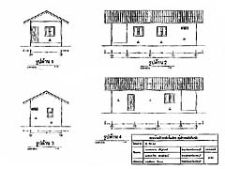

The conctruction plans were designed by the Technical College Phetchburi. This has the advantage that the homes will satisfy the needs of the government.

On 07. January 20005 the reconstruction of Ban Bangsak started.

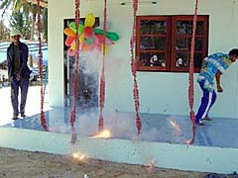
The working is so fast,that one month after the Tsunami, on January 26th, the first home was released to the media in Thailand and Gemany.

The team works so efficient that they believe to achieve the reconstruction of 30 homes in not more than three month. For that they have to work night and day. Rain season is standing in front of the door.

The special thing about the project is that Willi payed at the beginning each worker 150,-- Baht (3,-- Euro), later on 170,-- Baht. This meets the regular price for a work of this kind.

After one month, Willi does reorganise the groups. The people are getting more responsibility and trust. They do organize the construction side by themselves. As advantage Willi receives more time to work with the media. Willi doesn’t see himself as coordinator.

Aim of this action is to give the victims independancy and responsiblity by passing work to each one. They should feel to be needed and supported.

2. The sea gypsies (MORGAN)

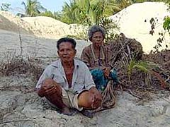
Willi Kothny realizes very fast that the
victims who he is working for are sea
gypsies. These so called „Morgan“ are a
small ethnic minority who just settled
down approximately 100 years ago. Thais call them „New Thais“.
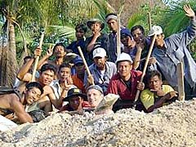

In the normal life these small groups were treated not very well. They receive disadvantages from officials and get the land they are living on sold to scupellous land lords.

Sea gypsies do earn their living by fishing and working what ever they can get. They are living with the nature. No one knows where they are coming from. People expect that they do have their roots in India and settled down in Thailand long time ago when they used to live their life as sea gypsies.

The majority of these „New Thais“ are analphabets and are not able to speak english. The chance of working in the tourism branch is very small. Financially they are not in the position to give their children a good education.

During the time working with the Morgan, Willi Kothny realized, that they do have a sense for responsibility and fairness. Willi decides to give them the opportunity to start evrything new. They deserve a better future.

3. Projects in the future

Willi Kothny did decide for three further projects, so that the Morgans will have a better chance in the future. A school project, easy tourism and a construction company might give them the chance of having a better future.

a. The school:
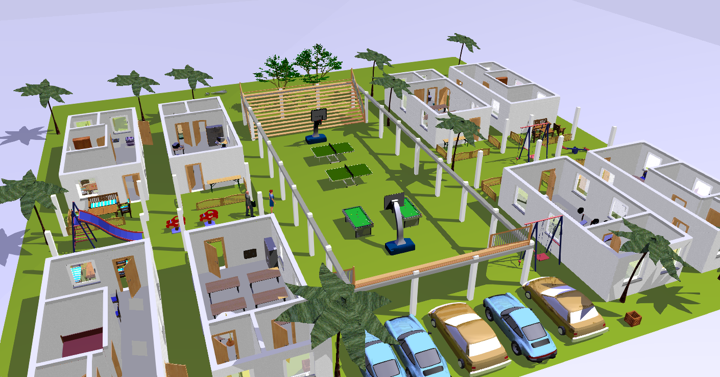

The construction of an extra school is already in process. As classroom the plans of the Technical College Phetchburi will be good enough. This has the advantage that no new plans must be drawn. In the center Mr. Kothny will do kind of meeting hall, so that the villagers will be able to do festivals or other things on it. It should be the heart of the project.

The financing for the teachers will be that a special amount of money will be paid to an account, so that from this account the financial aspect will be enough.
Until now these Morgans had no chance of having their children a good education. This extra school will be free of charge for the people in this area. The educational aspect is to have the needed material tought. This would be Thai, English, Computer and helping the kids getting their homework done. In other programs analphabets will be able to gain education.

b. Easy tourism:

Mr. Kothny did survey the people for information. As answere were in a big part, that the women did work in resorts and hotels already. So Willi did decide with the people together to build a resort for self management. The resort or homestay will be build
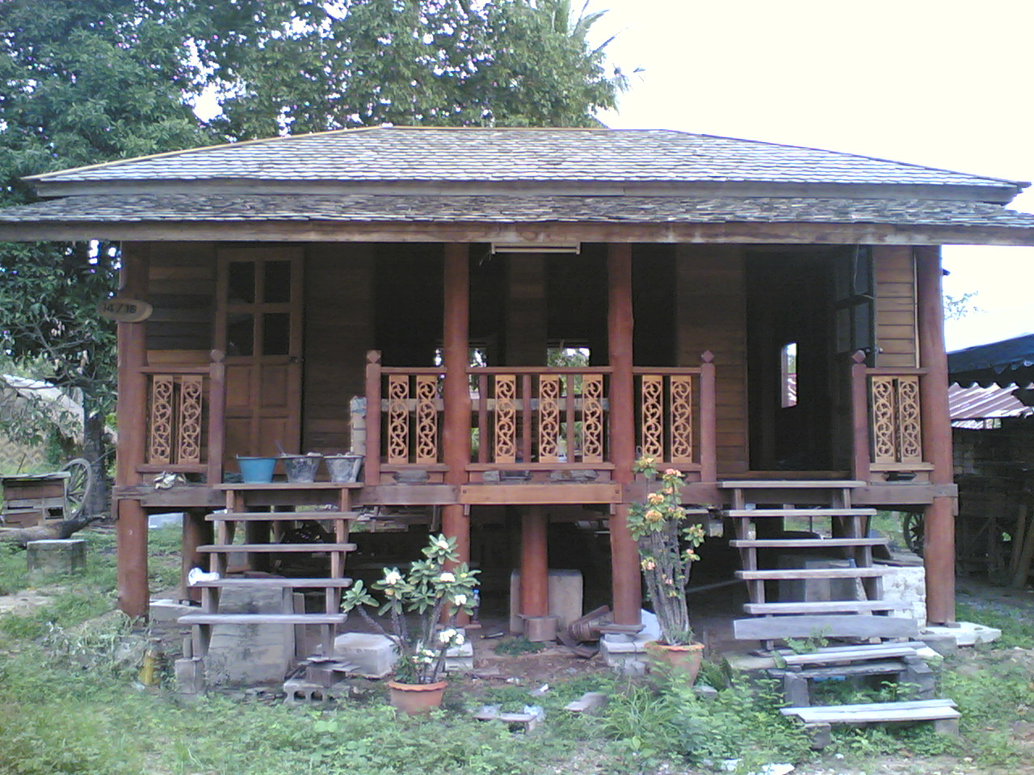
on approximately 10.000 m². The philosophy of the resort is not to have many tourists but to have tourists who are interested to li ve with the Morgans. Not quantity but quality is important. For getting the resort more interesting we decide that we will have different styles of buildings. That will be approximately 10 -15 bungalows. One aspect is that the women will not have to leave their children alone. Second, work for the future might be secured. Third, it is not necessary to teach them a new work.
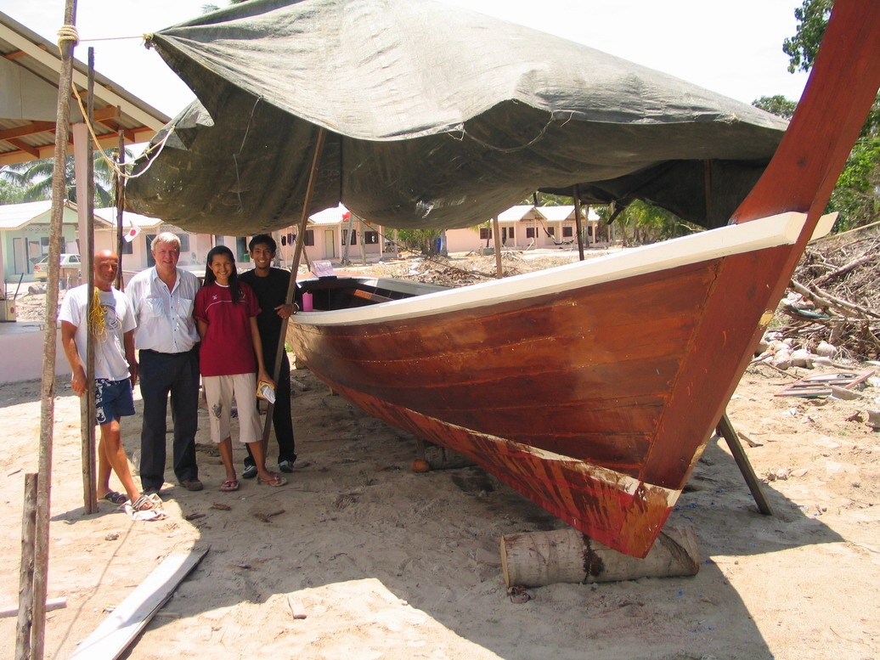
Another part of the easy tourism is to have
the former fishers their boats back. At the
beginning we decide to build ten boats,
but throughout our material, which we are
using we had other people asking us to
build their boats. At the moment we have
contact with Suphan P.P.R. Partnership Ltd,
who is willing to sell chorrie wood for the
price of 800 Baht per sqft³. The price might
go down, because of talks we are having
at the moment. So at the moment we are
building ten boats but are aiming to build ten more.
The positive aspect about chorrie wood is that these long tail boats are lasting for longer. Another aspect is the visual part. Especially for our resort, we will be in need of fisher boats. Fresh fish is necessary for the people themselves and their tourists. Second, having good boats will give us the opportunity to give tourists tours to other island and fishing tours. So the victims will do their usual work and are in the position to earn extra money by making tours.

Tsunami monument:

Two waves will be build in the center of the village. The red one contains the victims who did pass away and another bigger blue wave should stand for the people who did not forget these victims. It will include donators, volunteers, helper and workers

These those volunteers are welcomed guests and fortunatelly they might be those tourists the villagers are aiming for. Having a sense of passion, friendliness and heart.

c. construction company:
As we are building these homes with the people together, Willi got information that they are interested to have a construction company in the future. They told him some men did work on other construction sides before. Since the beginning until now “Willi hilft e.V.” did buy so many construction materials that Willi is in talks with some car companies, because a pick up and a truck will be needed. Another need for the truck is, that Willi just did make an agreement with Secretary General Mr. Chamniern Paul Vorratnchaiphan, Ph. D. and Mr. Chatsiri Thanmarom from the “building together association”, that Willi will buy equipment to produce bricks and roof parts. For that, Willi will need a truck to deliver these materials for other victims and people who will be interested. Dr. Paul and Mr. Chatsiri did show understanding and are willing to help as good as possible.

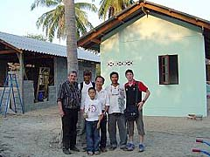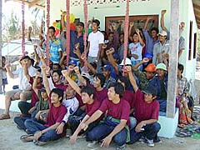

Self supply

In his working unit Willi did found a lot of unemployed villagers. One did build boats, another did furniture, some did work as worker on construction sides and some did work in resorts and restaurants as servants of other people. The Tsunami did destroy these jobs now.

The reconstruction of the village gives the people now the opportunity to work and to secure the future.

Boat constructor shell rebuild the old fleet. They will need other people to help and with that other work is secured.

Fisher men, will use these boats to do their former occupation. Extra money can be earned by taking tourists with them to fishing grounds and sight seeing tours.

The furniture worker, will be occupied with works to build furnitures for all these homes and bugalows.

The costruction workers, will be occupied with work lasting until the end of this year. Building homes for other victims and building the resort, extra school and the monument will employ them for a long time.

The servants, will have a lot of work with the restaurant and keeping the resort clean for the rest of their lives.

Willi Kothny is giving responsibility to almost everyone who is able to cope with the situation. They should at the end be able to live their life by themselves as they did before – with the small aspect of living it on a higher level – they shouldn’t be the Morgans like before, asking for help and beeing denounced by other people. They will get out with a risen head and a breast full of self-confidence! What these people did by building something small out of nothing is the same what Germany did after the World War II.: A small glooming community out of nothing.
But the small different is, that USA did help Germany. Now Germany is helping the Morgans.

The sea gypsies are wearing with proud the T- Shirt with the print on it
„MORGANS FOR WILLI, WILLI FOR MORGANS.

Aims:

→ Reconstruction of homes
→ Resort for self management
→ Boats for fishing and tours
→ Extra school for better chance
→ Production equipment for producing Interlocking Blocks and K- Tiles for own use and later on for business
→ Construction Company „Morgan Construction“
→ Water will be tested by laboraory for quality
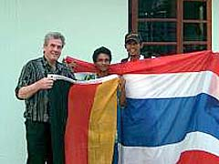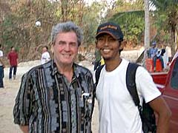

Sincerely Yours,



(Wiradech “Willi” Kothny)

